Chapter 5: Sequential Logic
Solutions to Problems: [2, 7, 9, 12, 13, 16, 18]

Problem 5-2:
Construct a JK flip-flop using a D flip-flop, a 4-to-1-line multiplexer and an inverter.

Solution:

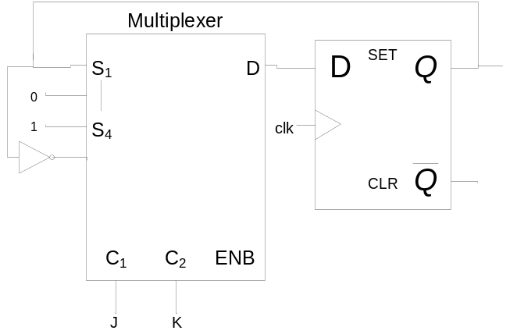

Problem 5-7:
A sequential circuit has one flip-flop Q, two inputs x and y, and one output S. It consists of a full-adder circuit connected to a D flip-flop, as shown. Derive the state table and state diagram of the sequential circuit.
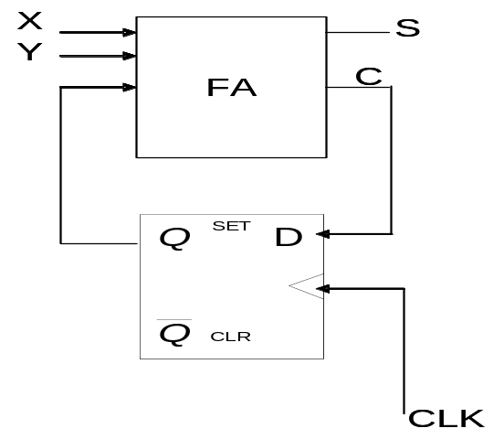

Solution:

FA equations:

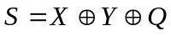
C = XY + XQ + YQ

Input equation:
D_{Q} = C
= XY + XQ + YQ (from the FA equations or from the K-map)

Characteristic equation:
Q(t+1) = D = XY + XQ + YQ

State equation:
Q(t+1) = C

State Table:

PRESENT STATE | INPUTS |  | NEXT STATE | OUTPUT
Q | X | Y | Q | S
0 | 0 | 0 | 0 | 0
0 | 0 | 1 | 0 | 1
0 | 1 | 0 | 0 | 1
0 | 1 | 1 | 1 | 0
1 | 0 | 0 | 0 | 1
1 | 0 | 1 | 1 | 0
1 | 1 | 0 | 1 | 0
1 | 1 | 1 | 1 | 1

State Diagram:
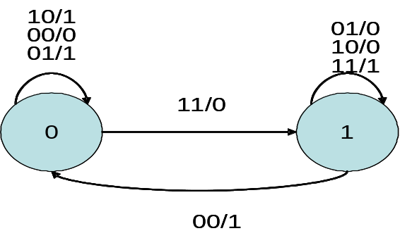

Problem 5-9:
A sequential circuit has two JK flip-flops A and B and one input x. The circuit is
described by the following flip-flop input equations :
J_{A} = x K_{A} = B'
J_{B} = x K_{B} = A

- Derive the state equation A(t+1) and B(t+1) by substituting the input equations for the J and K variables.
- Draw the state diagram of the circuit.

Solution:

State equation:
Q(t+1) = JQ' + K'Q

Characteristic equation:
A(t+1) = XA' + BA
B(t+1) = XB' + A'B
State Table:

PRESENT STATE |  | INPUT | NEXT STATE |  | FLIP-FLOP INPUTS
A | B | X | A | B | J_{A} | K_{A} | J_{B} | K_{B}
0 | 0 | 0 | 0 | 0 | 0 | 1 | 0 | 0
0 | 0 | 1 | 1 | 1 | 1 | 1 | 1 | 0
0 | 1 | 0 | 0 | 1 | 0 | 0 | 0 | 0
0 | 1 | 1 | 1 | 1 | 1 | 0 | 1 | 0
1 | 0 | 0 | 0 | 0 | 0 | 1 | 0 | 1
1 | 0 | 1 | 0 | 1 | 1 | 1 | 1 | 1
1 | 1 | 0 | 1 | 0 | 0 | 0 | 0 | 1
1 | 1 | 1 | 1 | 0 | 1 | 0 | 1 | 1
00
11
01
10
0
0
1
1
1
0
00
11
01
10
0
0
1
1
1
0
0, 1
State Diagram:

Problem 5-12:
Reduce the number of states in the following table and tabulate the reduced state table.

PRESENT STATE | NEXT STATE |  | OUTPUT
PRESENT STATE | X=0 | X=1 | X=0 | X=1
a | f | b | 0 | 0
b | d | c | 0 | 0
c | f | e | 0 | 0
d | g | a | 1 | 0
e | d | c | 0 | 0
f | f | b | 1 | 1
g | g | h | 0 | 1
h | g | a | 1 | 0

Solution:

States b,e are the same ,we will replace state e with state b .
States d,h are the same ,we will replace state h with state d .

PRESENT STATE | NEXT STATE |  | OUTPUT
PRESENT STATE | X=0 | X=1 | X=0 | X=1
a | f | b | 0 | 0
b | d | c | 0 | 0
c | f | b | 0 | 0
d | g | a | 1 | 0
f | f | b | 1 | 1
g | g | d | 0 | 1

States a,c are the same ,we will replace state c with state a .

PRESENT STATE | NEXT STATE |  | OUTPUT
PRESENT STATE | X=0 | X=1 | X=0 | X=1
a | f | b | 0 | 0
b | d | a | 0 | 0
d | g | a | 1 | 0
f | f | b | 1 | 1
g | g | d | 0 | 1

Problem 5-13:

Starting from state a, and the input sequence 01110010011,determine the output sequence
for:
- the state table of the previous problem and
- the reduced state table from the previous problem. Show that the same output sequence is obtained for both.

Solution:
(a) using the state table of the problem 5-12 :

state | a | f | b | c | e | d | g | h | g | g | h | a
input | 0 | 1 | 1 | 1 | 0 | 0 | 1 | 0 | 0 | 1 | 1
output | 0 | 1 | 0 | 0 | 0 | 1 | 1 | 1 | 0 | 1 | 0

(b) using the reduced state table of the problem 5-12 :

state | a | f | b | a | b | d | g | d | g | g | d | a
input | 0 | 1 | 1 | 1 | 0 | 0 | 1 | 0 | 0 | 1 | 1
output | 0 | 1 | 0 | 0 | 0 | 1 | 1 | 1 | 0 | 1 | 0

The same output sequence is obtained for both.

Problem 5-16:
Design a sequential circuit with two D flip-flops A and B, and one input x. When x=0, the state of the circuit remains the same. When x=1, the circuit goes through the state transitions from 00 to 01 to 11 to 10 back to 00, and repeats.

Solution:

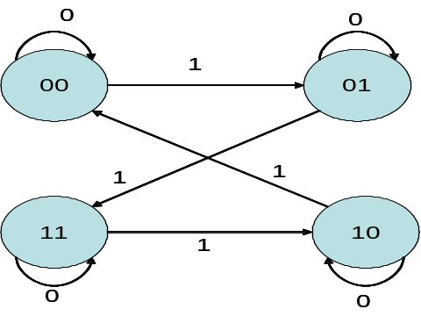
State Diagram:

State Table:

PRESENT STATE |  | INPUT | NEXT STATE
A | B | X | A | B
0 | 0 | 0 | 0 | 0
0 | 0 | 1 | 0 | 1
0 | 1 | 0 | 0 | 1
0 | 1 | 1 | 1 | 1
1 | 0 | 0 | 1 | 0
1 | 0 | 1 | 0 | 0
1 | 1 | 0 | 1 | 1
1 | 1 | 1 | 1 | 0

Characteristic equation:
Q(t+1) = D

Input equations or State equations :

A(t+1) = D_{A} (A,B,X) = ∑ (3,4,6,7)
B(t+1) = D_{B} (A,B,X) = ∑ (1,2,3,6)

K-maps :
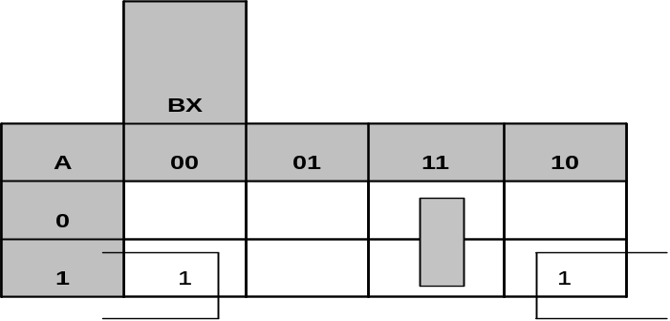
D_{A}

D_{A} = BX + AX'

D_{B}
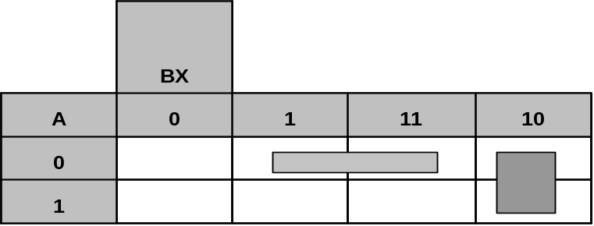

D_{B} = A'X + BX'

Circuit Diagram :

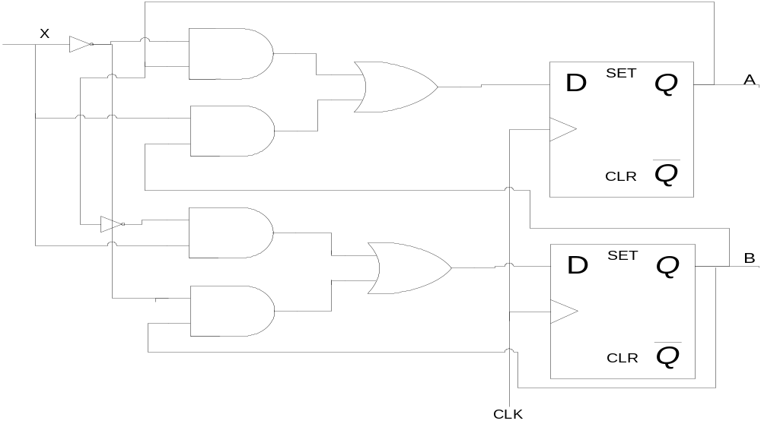
Problem 5-18:
Design a sequential circuit with two JK flip-flops A and B and two inputs E and x.If E =0 ,the circuit remains in the same state regardless of the value of x. When E =1 and x=1, the circuit goes through the state transitions from 00 to 01 to 10 to 11 back to 00,and repeats. When E =1 and x=0, the circuit goes through the state transitions from 00 to 11 to 10 to 01 back to 00,and repeats.

Solution:

State Diagram:
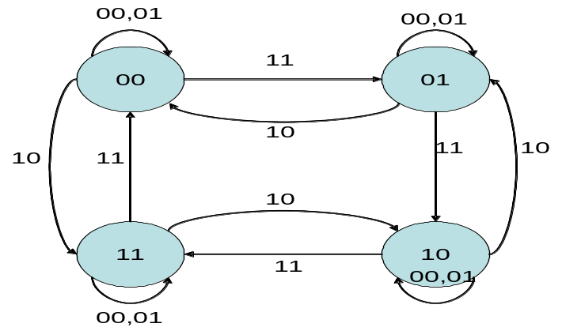

State Table:

PRESENT STATE |  | INPUT |  | NEXT STATE |  | FLIP-FLOP INPUTS
A | B | E | X | A | B | J_{A} | K_{A} | J_{B} | K_{B}
0 | 0 | 0 | 0 | 0 | 0 | 0 | X | 0 | X
0 | 0 | 0 | 1 | 0 | 0 | 0 | X | 0 | X
0 | 0 | 1 | 0 | 1 | 1 | 1 | X | 1 | X
0 | 0 | 1 | 1 | 0 | 1 | 0 | X | 1 | X
0 | 1 | 0 | 0 | 0 | 1 | 0 | X | X | 0
0 | 1 | 0 | 1 | 0 | 1 | 0 | X | X | 0
0 | 1 | 1 | 0 | 0 | 0 | 0 | X | X | 1
0 | 1 | 1 | 1 | 1 | 0 | 1 | X | X | 1
1 | 0 | 0 | 0 | 1 | 0 | X | 0 | 0 | X
1 | 0 | 0 | 1 | 1 | 0 | X | 0 | 0 | X
1 | 0 | 1 | 0 | 0 | 1 | X | 1 | 1 | X
1 | 0 | 1 | 1 | 1 | 1 | X | 0 | 1 | X
1 | 1 | 0 | 0 | 1 | 1 | X | 0 | X | 0
1 | 1 | 0 | 1 | 1 | 1 | X | 0 | X | 0
1 | 1 | 1 | 0 | 1 | 0 | X | 0 | X | 1
1 | 1 | 1 | 1 | 0 | 0 | X | 1 | X | 1
K-maps :

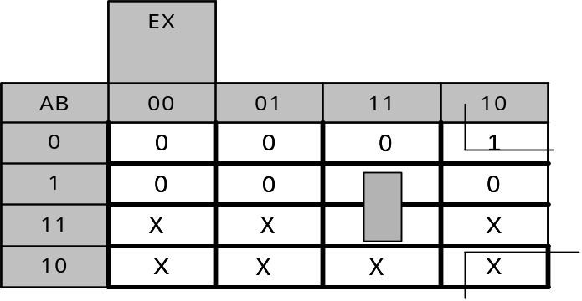
J_{A}

J_{A} = BEX +B'EX' = E (BX)'

K_{A}

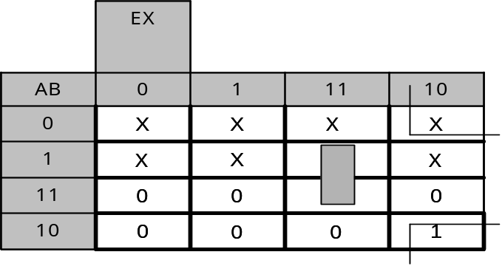

K_{A} = BEX +B'EX' = E (BX)'

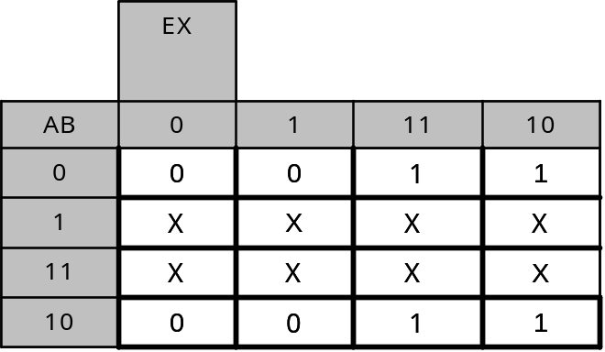
J_{B}

J_{B} = E
K_{B}
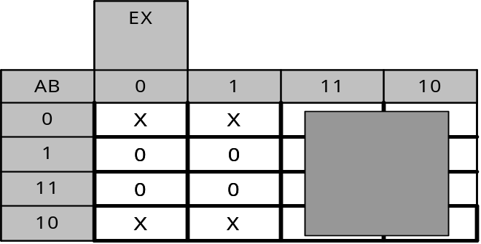

K_{B} = E

Circuit Diagram :

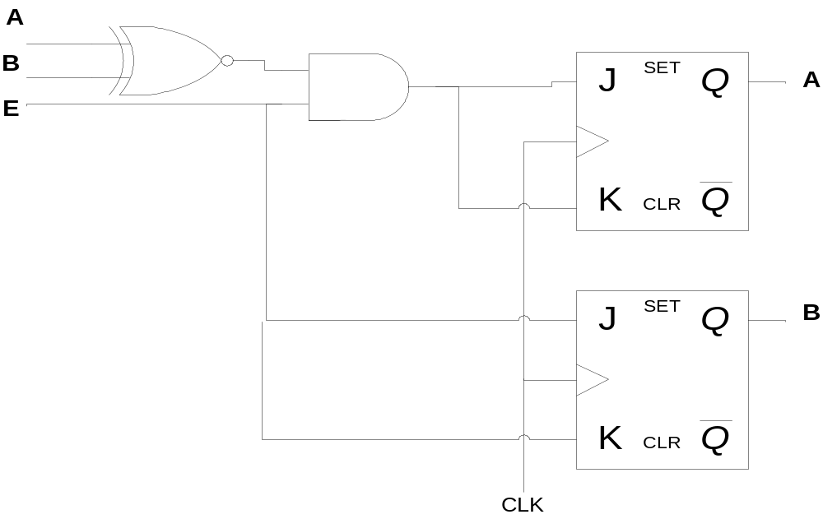
This sequential circuit behaves like a 2-bit up-down-counter, with E the enable of the whole counter, and resets when it finishes counting , when X=1, it behaves like an up-counter, when X=0 ,it behaves like a down-counter.

